EXP. NO: 26
MATLAB SIMULATION OF SINGLE-BIT ERROR DETECTION DATE: AND CORRECTION USING SYNDROME VECTORS IN LINEAR BLOCK CODES
Objectives :
- To simulate single-bit error detection and correction using syndrome vector decoding in a linear block coding scheme with MATLAB.
- To analyze the encoding, error detection, syndrome computation, and correction process by comparing the transmitted, received, and corrected codewords.

Procedure:
1. Open the MATLAB software and create a new script file.
2. Clear the command window, workspace, and close all previously opened figure windows.
3. Define the message bit sequence.
4. Generate the corresponding codeword using a linear block encoder.
5. Introduce a single-bit error into the encoded codeword.
6. Compute the syndrome vector using the parity-check matrix.
7. Identify the error location from the syndrome vector.
8. Correct the detected error in the received codeword.
9. Recover the original message from the corrected codeword.
10. Display the encoded codeword, received codeword, and corrected message.
11. Plot the encoded and received codewords for comparison.
12. Verify that the corrected message matches the original transmitted message.
PROGRAM :
clc;
clear;
close all;
% (7,4) Hamming Code
msg = [1 0 1 1];
% Encode
code = encode(msg,7,4,'hamming/binary');
% Introduce Single-Bit Error
rx = code;
rx(3) = ~rx(3); % Flip one bit %
Decode and Correct Error
dec = decode(rx,7,4,'hamming/binary');
% Display Results
disp('Message Bits:')
disp(msg)
disp('Encoded Bits:')
disp(code)
disp('Received Bits (with error):')
disp(rx)
disp('Corrected Message:')
disp(dec)
% Plot
figure;
subplot(2,1,1)
stem(code,'filled')
title('Encoded Codeword')
grid on
subplot(2,1,2)
stem(rx,'filled')
title('Received Codeword with Single-Bit Error')
grid on
Output:

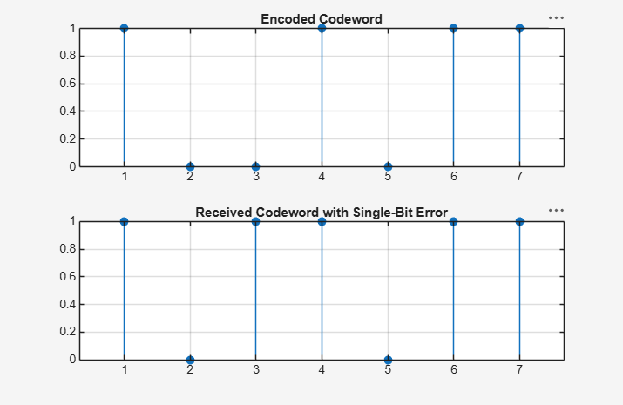
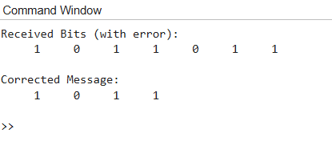
Result:
- The single-bit error detection and correction process using syndrome vectors was successfully implemented in MATLAB, and the introduced error was correctly identified and corrected.
- The comparison of the encoded, received, and corrected codewords confirmed the effectiveness of linear block codes in detecting and correcting single-bit transmission errors.

